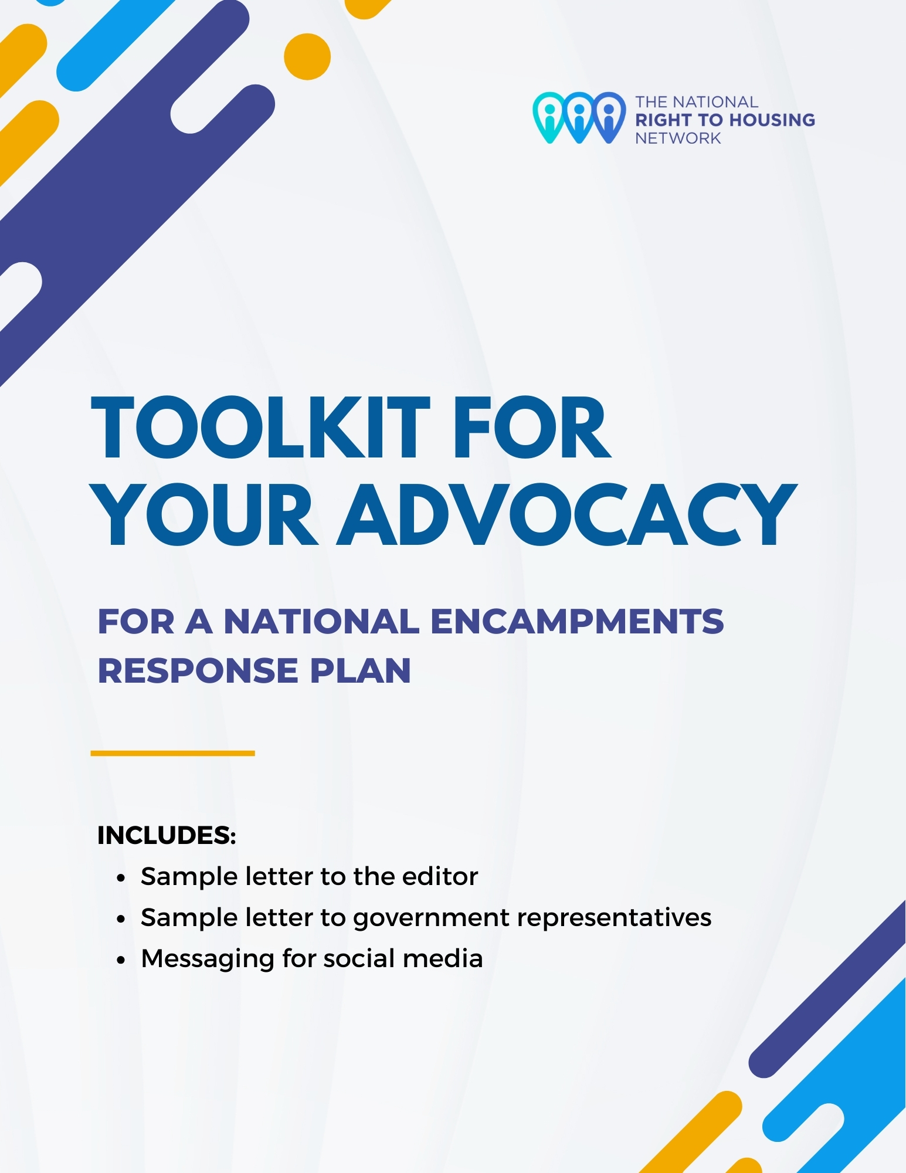

Contents
1. Sample Letter to the Editor 1
2. Sample Letter to Government Representatives 3
3. Social Media Shareables 5

1. Sample Letter to the Editor

What is a letter to the editor?

A letter to the editor is a message that anyone can write to a news publication on a specific issue. It can be written in response to an article, column, etc., or as a reaction to or notification of a newsworthy event (for example what’s happening in your community in relation to encampments).

Letters to the editor can be a powerful tool in your advocacy work because they are the second most read section in a newspaper (the first being the front page). As a result, they are an effective way to call attention to the issue of encampments and a human rights response to encampments.

Writing Tip: Try to keep your letter under 250 words and use short paragraphs or key points when possible. To send your letter to the editor, check your local newspaper for contact information. An email should be available, though the publication may also be open to publishing letters that are submitted by mail!

Sample Letter to Editor

Dear Editor,

Canada's homeless encampments are a national human rights crisis.
A growing number of people in Canada are having to live in tents or informal shelters to survive due to a lack of affordable housing, limited support services, and nowhere safe to go.

In February of this year, the Federal Housing Advocate, a human rights watchdog, released her findings about the factors leading to the rise in encampments and, most importantly, the concrete measures that must be taken by all governments – including her urgent call for a National Encampments Response plan to be developed by August 31, 2024. Minister of Housing, Infrastructure, and Communities, Sean Fraser, now has 120 days to respond to these human rights findings.

Encampments are a national human rights crisis because people living in encampments face harassment and violence from police, bylaw officers, and members of the public. They do not have access to basic services like clean water or heat. Some have suffered harm or have died as a result of exposure, fire, overdose, and other threats to life and safety. These conditions amount to violations of fundamental human rights, including the human right to housing.

In my own community…[explain why you care about this in 2-3 sentences – make it personally and locally meaningful. Some questions to consider may be: what has happened recently in your community? What evidence about homelessness in your community is relevant? What would it mean to engage with people in encampments in your community?]

Encampments exist only because of a larger, systemic failure to uphold the right of all people to permanent, adequate housing without discrimination.

A human rights approach to solving this national crisis is sorely needed. We can do this by engaging with people in encampments about what they need so we can find solutions to homelessness that genuinely respect their dignity and uphold human rights.

To learn more about the Advocate’s urgent call for action: https://www.housingchrc.ca/en/publications/upholding-dignity-and-human-rights-federal-housing-advocates-review-homeless

[Name]

[City, Province/Territory]

2. Sample Letter to Government Representatives

Write a letter to your government representative at the municipal, provincial/territorial, or federal level to call for a human rights response to encampments. Resources to help you find your government representative can be found under the sample letter below.

For more content on recommendations for each level of government, see the fact sheets for municipal governments and provincial/territorial government developed by the Federal Housing Advocate (to be released).

Sample Letter to Government Representatives

[Date]
[Name of Government Representative]
[Address of Government Representative]

Re: Federal Housing Advocate calls for human rights responses to homelessness in encampment report

Dear [Name]:

My name is [your first and last name] and I am a [service provider/advocate/community member] who resides in your [riding/ward/community]. I have recently learned that in February of this year, the Federal Housing Advocate, a human rights watchdog, released her findings about the factors leading to the rise in encampments and, most importantly, the concrete, human rights-based measures that must be taken by all governments.

I am writing to encourage you to review her findings and consider your role in implementing recommendations from the report: https://www.housingchrc.ca/en/publications/upholding-dignity-and-human-rights-federal-housing-advocates-review-homeless. In particular, I urge you to consider to support and actively participate in a National Encampments Response Plan.

There has been a significant rise in encampments in the last five years, and particularly since the COVID-19 pandemic. Encampments are now being reported in communities all across the country – in both large and small municipalities, as well as in more rural areas. Encampments are not a safe or sustainable solution for housing. For people living in these encampments, every day is a matter of life and death.

At the same time, encampments represent an effort by people who are unhoused to claim their human right to housing and meet their most basic needs for shelter. As the Federal Housing Advocate found, encampments are often people's only housing option, or the only option that meets their needs for safety, security and dignity.

In her final report, the Federal Housing Advocate made two key findings: First, encampment residents are at dire risk of harm due to the failure to uphold their basic rights. Second, the encampments exist only because of a larger, systemic failure to uphold the right of all people to adequate housing without discrimination.

[explain what this means to you – what has happened in your community?]

The absence of effective coordination between the many agencies, departments and jurisdictions involved limits the effectiveness of responses to the homelessness crisis. While municipalities are on the frontlines in responding to encampments, they don't have all the powers and resources they need to provide human rights-based services. Provinces and territories must work closely with municipalities and the federal government must play a leadership role.

In other words, this national crisis calls for an urgent and coordinated national response.

Sincerely,

[Name]

[Address including Postal Code]

How to find your local government representative
Start by Googling “[Insert the Name Of Your City/Town/Region] city council”
This website lists some of the major cities in Canada along with links to the City Councilors for each ward: https://oncanadaproject.ca/findyourrep.

How to find your provincial or territorial government representative
Ontario: Click Here | Quebec: Click Here
British Columbia: Click Here | Alberta: Click Here
Saskatchewan: Click Here | Manitoba: Click Here
Nova Scotia: Click Here | New Brunswick: Click Here
Yukon: Click Here | Nunavut: Click Here
Prince Edward Island: Click Here
Newfoundland and Labrador: Click Here
Northwest Territories: Click Here

How to find your federal government representative
Put in your postal code here: https://www.ourcommons.ca/members/en. Under the “contact” tab, you will find your Member of Parliament’s email address which should end in @parl.gc.ca. If you’re writing to a federal Minister of Member of Parliament, use this style of address guide: https://www.canada.ca/en/canadian-heritage/services/protocol-guidelines-special-event/styles-address.html].

3. Social Media Shareables

Share the follow messages on social media such as Twitter/X, Facebook, or LinkedIn to promote this toolkit as well as information on the Federal Housing Advocate’s call for a National Encampments Response Plan!

Sample Social Media Messages

- Canada’s encampments are an urgent human rights crisis that requires a national response. Learn more about what a National Encampments Reponses plan should look like & get practical tools for your advocacy work in your community!: https://housingrights.ca/encampments-in-canada/

- Encampments are a human rights crisis that requires an urgent National Encampments Response plan. Learn more about the state of encampments in Canada + get practical tools to advance a rights-based approach in your community: https://housingrights.ca/encampments-in-canada/
Click here to share these messages on Twitter/X.

Click here to share these messages on Facebook.

Click here to share these messages on LinkedIn.

